Physics 20 Lesson 19H Banked Curves

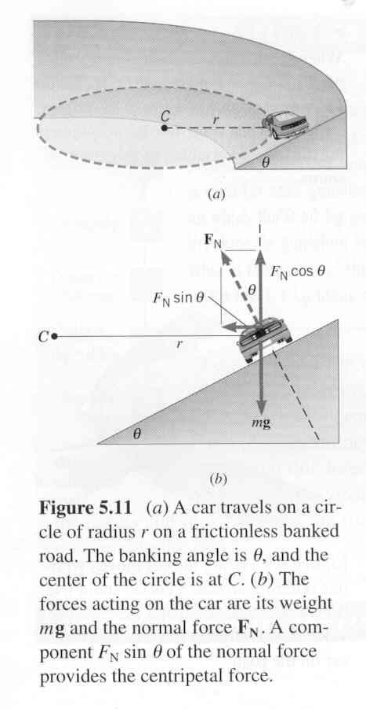
Forces on banked curves
The banking of curves can reduce the chance of skidding because the normal force acting on the car will have a component towards the center of the circle, thus reducing or eliminating the need for friction. In fact, for a given angle of banking, there will be one speed for which no friction force is required. In this case, there are only two forces acting on the car, F_{g} and F_{N}.

Resolve F_{N} into x and y components.
Note: 1) F_{N} ≠ F_{g}
2) θ = θ

Since
cosθ = -F_{g} / F_{N}

then
F_{N} = -F_{g} / cosθ

F_{N}

(F_{N} = F_{g} cos θ)

θ
θ
F_{g}
F_{N}sin θ
F_{N} cos θ

F_{N} sinθ supplies the centripetal force necessary to negotiate the curve, and F_{g} = F_{N}cosθ since the car does not accelerate vertically.

1. F_{g}= -F_{N} cosθ
F_{N} = -F_{g} / cosθ
F_{N} = (-9810 N / cos 15°)
F_{N} = 10156.1 N

Sample Problem

A 1000 kg car travels around a frictionless curve of radius 100 m. If the curve is banked at 15.0° to the horizontal, what is the maximum speed that the car can safely round the curve?

3. F_{c} = mv²/r
v² = F_{c}r/m
v² = (2628.6 N) (100 m)
1000 kg
v² = 262.9
v = 16.2 m/s
2. F_{c} = F_{N} sinθ
F_{c} = (10156.1) sin (15°)
F_{c} = 2628.6 N

F_{C}
F_{N}
F_{g} = mg
= (1000 kg)(-9.81 m/s²)
= -9810 N
15°
15°
100 m
The banking angle of the road, θ, is chosen so that the horizontal component of the normal force provides the centripetal force for a particular posted speed, called the design speed.

Often, highways use banked curves so that a car, without friction, and regardless of its mass, can round the curve safely at the posted speed.

Here, only F_{g} and F_{N} act. So F_{Net} = F_{g} + F_{N} and F_{c} = F_{g} + F_{N}

F_{N}
F_{g}
θ

F_{g}
F_{N}
F_{net} = F_{c}
θ

To calculate the banking angle:
tanθ = F_{c} = mv²/r = v²
F_{g} mg rg

Sample Problem

A car must round a curve of radius 475 m safely at a seed of 79 km/h. What is the angle at which the curve must be banked?

v = 79 km/h = 21.94444 m/s

tan θ = v²/rg = (21.94444m/s)²/475 m X 9.81 m/s²
θ = 5.9°

The same principle may be applied to other situations. For instance, in order for a plane to make a turn it must also bank its wings with respect to the ground. This action allows some of the lift force on the wings to be translated into a centripetal force, thus allowing the plane to make a sharper turn.
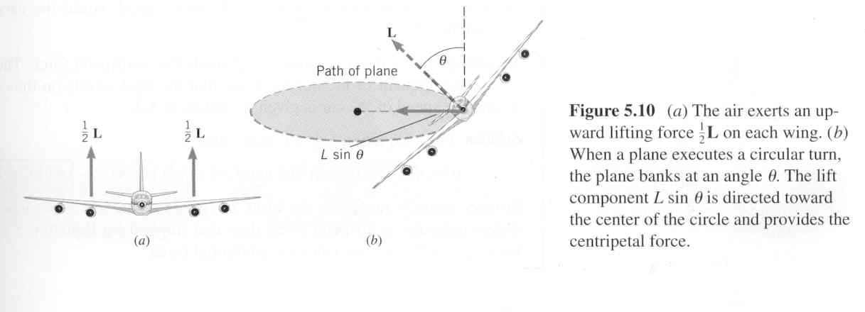

Complete the attached assignment.

Physics 20H Banked Curves

- What is the maximum speed a car is able to round a 125 m curve in a highway under very icy conditions (friction is negligible) if the banking angle is 18°?

- A 745 m curve on a racetrack is too banked for cars travelling at 90 m/s. At what angle should it be banked if it is going to be used under very icy conditions?

- A car rounds a very icy curve in the highway that is banked at an angle of 16°, while travelling at a speed of 100 km/h. What is the maximum radius of the curve?

- A car travels on a circular banked track of radius 300 m and having a banked angle of 22°. What is the minimum time for one lap of the track if the car does not rely on friction to hold it on to the track?

- A car is required to round a curve of radius 50 m banked at an angle of 16°. If the 1200 kg car is travelling at 70 km/h, will frictional force be required? If so, how much, and in what direction?

- A car rounds a curve of radius 50 m at a speed of 50 km/h.

- What is the banked angle so that friction is not required?
- If the same angle is used for a car travelling at 90 km/h, what minimum coefficient of friction is necessary for the car not to skid?

